## Name: Sagheer Muhammad

## Batch: 2

## Project: Data Mining

## GitHub Link: https://github.com/sagheer01

**Define meta data in mysql workbench or any other SQL tool**

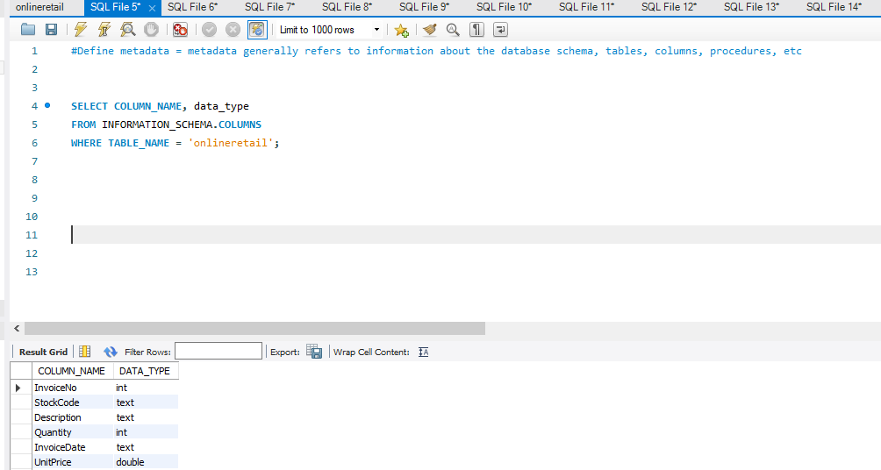

**What is the distribution of order values across all customers in the dataset?**

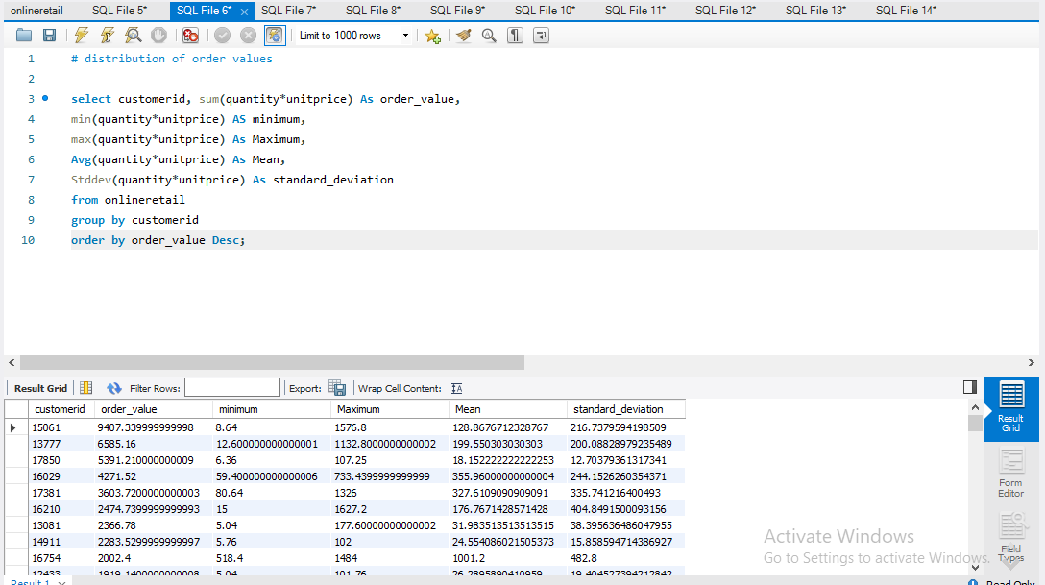

**How many unique products has each customer purchased?**

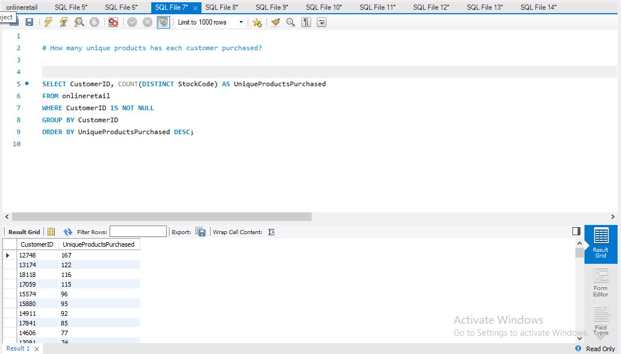

**Which customers have only made a single purchase from the company?**

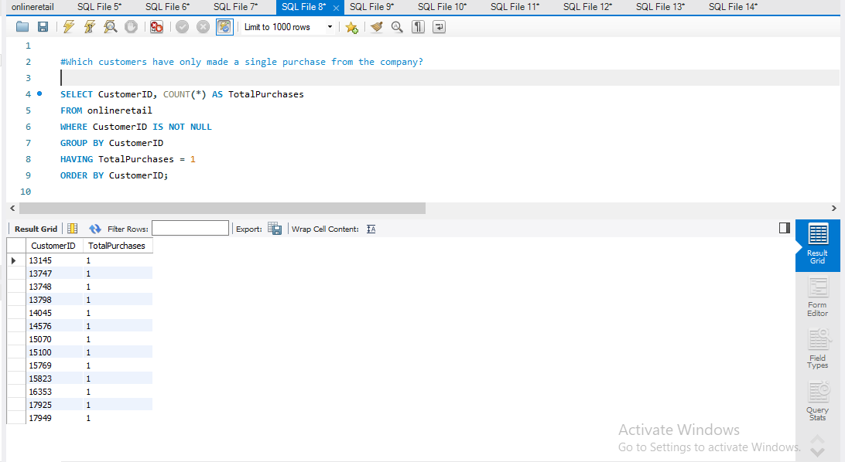

**Which products are most commonly purchased together by customers in the dataset?**

## Advance Queries

**1.      Customer Segmentation by Purchase Frequency**

**2. Average Order Value by Country**

**3. Customer Churn Analysis**

**Product Affinity Analysis**

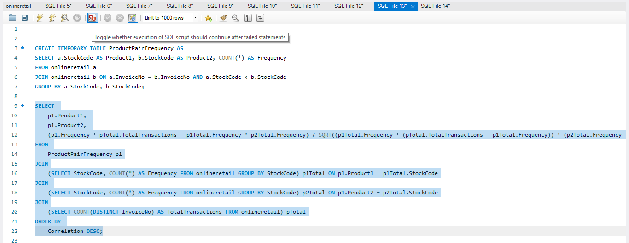

**5. Time-based Analysis**

